My Days of No Manifestations are Over!
Romans 8:19 NLT. "19 For all creation is waiting eagerly for that future day when God will reveal who his children really are.
All through 2021, while many will be begging, I will be giving! Proverbs 11:24-25/ Proverbs 28:27
In 2021, while many may be living with hunger, I will be distributing food! 1 Timothy 6:17-19/ Matthew 25:31-40
As I follow divine guidance, wonders without end will be my experience all through the year 2020 and beyond! Psalm 23:1-6/ Isaiah 48:21
As I maintain my covenant walk with God, my showers of blessing will continue to come down! Ezekiel 34:26/ Deuteronomy 28:1-13
As I continue to serve God all through 2021, I will be singing breakthrough songs all the way through! Psalm 126:1-6/ Psalm 35:27
As I continue to put the word of God to work, my life will no longer be a question mark, but an exclamation mark among men! Matthew 13:54/ Isaiah 60:1-3
My Year of Overcoming Oppressions Has Come!
Isaiah 63:4 NLT. "For the time has come for avenge my people, to ransom them from their oppressors."
Hebrews 2:3 NLT. "So what makes us think we can escape if we ignore this great salvation that was first announced by the Lord Jesus himself and then delivered to us by those who heard him speak?"
As a covenant child, God’s vengeance will answer in the camp of my enemies this year! Isaiah 63:4/ Luke 18:7-8/ Psalm 94:1
As I continue to make bold declarations, whatever is sitting on any aspect of my destiny, will be unseated this year! Psalm 81:10-14/ Proverbs 18:21
As I continue to put the word to work, seemingly impossible barriers will give way to me! Exodus 14:15/ Psa 114:3-7
As I continue to walk in the fear of the Lord, in the day of famine I will be satisfied! Ps. 33:18-19/ Ps. 37:18-19

Because marriage is a good thing and they that serve the Lord shall not lack any good thing, my marital destiny is settled this year! Proverbs 18:22/ Psalm 34:10
As a covenant child, every form of marital problems around my life are finally broken this year! Psalm 68:6/ Numbers 23:23
As I continue to serve God, I will not suffer any assault of the wicked anymore! Psalm 105:13-15

My Season of Celebrating Has Finally Come!

Isaiah 48:21 NLT. "They were not thirsty when he led them through the desert. He divided the rock, and water gushed out for them to drink."
As I continue to follow God’s leading, only goodness and mercy will be following me all through the year 2021! Psalm 23:6.
Through my undying love for God, the kind of turnaround that I have never imagined will begin to take place in my life beginning from this year! Psalm 126:1-6/ 1 Corinthians 2:9
As I continue to dwell in the secret place of the Most High, I will be exempted from all evils in 2021 and beyond! Psalm 91:1-16.
As I continue to engage in promoting the kingdom of God through prayers, all my secret tears will be turned to public testimonies this year! Psalm 30:5
As I continue to serve God diligently, I will spend my days in prosperity, and my years in pleasures! Job 36:11/ Psalm 35:27

So Shall it be as I have declared in Jesus mighty Name, Amen. Num. 14:28
Jesus is Lord
Pastor Dr. Steve Fagbule
Senior Pastor

Covenant of Faith Family Ministries Int’l
Covenant_City
6269 E Kings-Canyon Rd, Fresno CA 93727
 (559) 570-8400 / (559) 269-4898
www.covenantfaithfamily.org
 covenantfaithfamily@gmail.com
COVENANT FAMILY PERSONALIZED PROPHETIC DECLARATIONS FOR
YEAR 2021
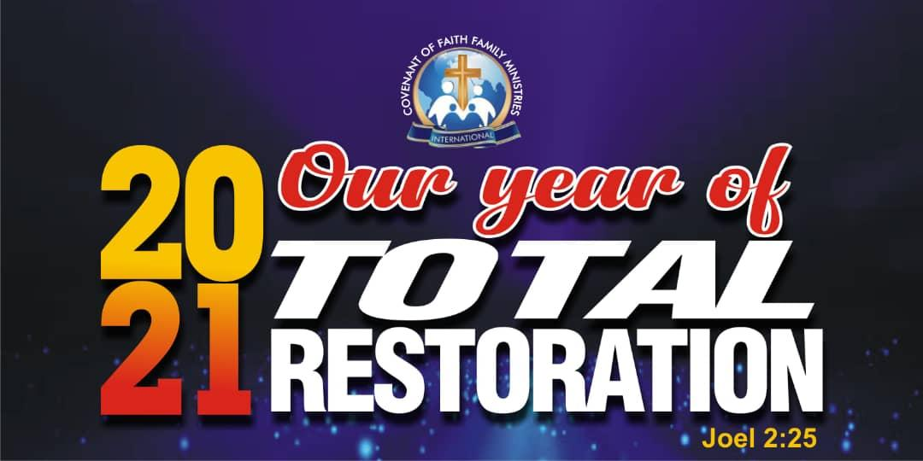
The Spirit of the Lord spoke through my Prophet in the house saying, “The year 2021 demands Personal Responsibility for maximum delivery”. Therefore, as I accept full responsibility, the prophetic agenda for 2021 ‘Total Restoration’ shall fully deliver in my life with undeniable proofs – 1 Timothy 1:18
With faith in God and in my prophet and according to 2 Chronicles 20:20, I take delivery of the following prophetic packages ordained for me in 2021.
My Year of New Beginnings
ISAIAH 43:18-19.“Do not call to mind the former things, Or ponder things of the past. 19 "Behold, I will do something new, Now it will spring forth; Will you not be aware of it? I will even make a roadway in the wilderness, Rivers in the desert.”:
• As I maintain my covenant walk with God all through the year 2021, while others will be drying up, I will be flourishing! Genesis 47:15-27
As I continue to serve God with joy and gladness, God will make me to laugh, and all that hear will laugh with me! Genesis 21:6/ Psalm 35:27
As I seek first the kingdom of God throughout the year 2021, I will never lack bread and water on my table! Exodus 23:25/ Matthew 6:31-33
Because I have made my choice to serve the Lord, I will continually increase more and more and my path will become brighter and brighter. Proverbs 4:18 / II Chronicles 26:3-5
As I walk in the light of scripture, the destructions and devastations of these hard times shall never come near my home Psalm 91:7
My Days of Supernatural Breakthroughs are here!
As I remain on course with divine plans, I will be breaking forth on every side in these hard times!
Joel 2:1-11/ Isaiah 48:21

In 2021 and by my commitment to practicing the word, no matter the heat on this earth, it will not affect me and my household! Exodus 9:1-7/ Malachi 3:6-11
Because I am attached to this prophetic family, whatever clears the way for covenant family church begins to clear the way for me and my household! 1 Samuel 10:5-6/ II Kings 2:12-15
Because of my covenant walk with God, my children will emerge as high flyers in their lifetime! Psalm 112:1-3/ Genesis 22:16-18
As I walk in obedience to the commandment of scriptures, my household will emerge as a family of giants! 1 Samuel 2:22-30/ Isaiah 60:1-3/8-22
In 2021 as I walk in the fear of the Lord, I will be divinely guided into realms of supernatural abundance and breakthroughs. Isaiah 58:11-12/ Psalm 23:1-6
My Days of Total Health are here!
Exodus 23:25-26. "You must serve only the Lord your God. If you do, I will bless you with food and water, and I will protect you from illness. 26 There will be no miscarriages or infertility in your land, and I will give you long, full lives."
By my faith in the finished work of Christ, my health will be fully restored this year! Jeremiah 30:17 / Matthew 9:27-29
In 2021, through the revelation of the word, health and vitality will be my testimony! Job 33:21-25
Throughout 2021, I will not need any form of medication to stay healthy and strong! Jeremiah 30:17
Every medical verdict against me from the past is changed to a testimony in 2021.Matthew 9:20-22
In 2021, whatever sickness and disease that doesn’t exist in heaven will cease to be in my body and in my household! I John 4:17
Every generational curse, spell and enchantment is dropping off of my life this year! Galatians 3:13. Nehemiah 13:2
Every spirit of infirmity tormenting my life is cursed right now! Luke 13:11-13
I am free from every form of sickness and disease this year! Matthew 8:1-2
Whatever does not glorify God in my body is cursed today! I Corinthians 6:20
Every age long ordeal in my life comes to an end right now! Deuteronomy 28:59
Every planting of the devil in my body, in terms of sickness, diseases, pains, discomforts and afflictions is rooted out right now! Matthew 15:13
As an ambassador of Christ, reconciling the world back to God through soul winning, I will continue to live a sickness-free life! John 15:1-2 / Proverbs 13:17
As I continue to give to the poor, I will be totally delivered from every affliction of sickness and disease! Psalm 41:1-3
From Now On, Money Shall become a non-Issue in my life!
Job 22:21-25 NLT. "21 Submit to God, and you will have peace; then things will go well for you. 22 Listen to his instructions, and store them in your heart. 23 If you return to the Almighty, you will be restored - so clean up your life. 24 If you give up your lust for money and throw your precious gold into the river, 25 the Almighty himself will be your treasure. He will be your precious silver!"
Through my commitment to covenant practice, l WILL be financially free this year! Deuteronomy 8:18/ 2 Corinthians 9:6-8
As I maintain a quality covenant walk with God, in the midst of this economic meltdown, I will be scaling new heights! Psalm 35:27
Through the mystery of tithing, the time of economic downturn in the world will be the time of financial increase for me! Malachi 3:10-11/ Psalm 37:18-19
As I remain committed to kingdom advancement giving, my financial dominion will be established this year! Haggai 1:5-14/ 1 Kings 8:17-18
Because of my raw obedience to the law of giving and receiving, money will become the least of my concerns all through 2021! Job 22:21-25/ 2 Corinthians 9:6-8

In 2021, as giving and receiving becomes my lifestyle, supernatural abundance will become my testimony! 2 Corinthians 8:1-3/ Philippians 4:15-19
In 2021, as I take care of God’s house he will take care of my house.
In 2021, as long as I continue to seek the Lord, he will make me to prosper

